Name ______________________

**LIMITING FACTORS LAB**

OBJECTIVES:

- to learn about various limiting factors that influence population dynamics

- to investigate which factors affect yellow perch in Lake Winnipeg

KEY TERMS:

- natural disasters: *disasters caused by nature*

- density: *organisms per unit area*

- toxic: *poisonous*

- tail races: *area of water located behind a dam*

- aquatic: *taking place in or on the water*

- penetrate: *to enter or force a way into*

- depletion: *the use or consumption of a resource*

- turbid: *degree of cloudiness of water*

- tributaries: *a stream that flows into a larger stream or other body of water*

- invasive: *moves in without right or permission, intrusive*

TASKS:

Read the notes on limiting factors. Then, using the knowledge you have gained, read the next set of notes to find all of the limiting factors that affect yellow perch in Lake Winnipeg. Using the work sheet provided on page 4, try to identify as many limiting factors as possible and classify them as density independent or density dependent factors. Then answer the questions on pages 4 and 5.

**LIMITING FACTORS**

All living things need food, water, shelter and space to survive. As long as organisms have all of these things available to them their population will continue to grow. However, populations cannot grow forever. Some form of environmental resistance will stop the population’s growth. The form of environmental resistance is called a limiting factor since it limits the population. However, limiting factors may also increase a population. We will look at many different limiting factors and classify them into density independent factors and density dependent factors.

**DENSITY INDEPENDENT FACTORS**

Density independent factors can affect a population no matter what it’s density is. For example: natural disasters, temperature, sunlight, human activities, physical characteristics and behaviors of organisms affect any and all populations regardless of their densities.

* + **Natural disasters** such as droughts, floods, hurricanes and fires can be devastating to aquatic life. For example, a severe drought could lower the water levels of Lake Winnipeg and decrease its carrying capacity. Thus, the fish population would decrease.
  + **Temperature** influences the activity and growth of organisms. Temperature also determines which type of organisms can live in a lake. Usually, the higher the water temperature, the greater the activity in a lake. However, all aquatic species have a preferred temperature range. If temperatures vary too much out of this range the species will either die or move to a different location. Temperature also influences the chemical properties of water. The rate of chemical reactions in the water increases as temperature increases. For example, warm water holds less oxygen than cool water, so even though there is more activity in warm water there may not be enough oxygen for the activity to continue for long periods of time.
  + **Sunlight** can only penetrate to a depth of 30 meters in water. Thus most photosynthesis in aquatic environments occurs near the surface. This means that most plants cannot grow if they are at the bottom of a deep lake.
  + **Human activities** can also affect population dynamics. For instance, lake sturgeon spawn in fast water and sometimes use the “tailraces” of hydroelectric dams. However, the water level in this location often drops suddenly and the eggs die because they become exposed.
  + **Physical characteristics** of organisms can affect their population. Many organisms have adapted and evolved in order to increase their chance of survival. For example, some species of fish have colored markings to warn predators that they may be toxic. Or, some species use camouflage colors to help them hide and avoid being eaten.
  + **Behaviors** of organisms can also affect their population. For example, some species migrate to find new food sources or to mate. Some organisms create societies or feeding territories. For instance, white bass live in schools and work together to drive emerald shiners to the surface for feeding. Some species may have mating or courtship behaviors that affect their population.

**DENSITY DEPENDENT FACTORS**

Density dependent factors can only affect a population when it reaches a certain density. For example, competition, predation, disease, parasitism, crowding, and stress are all factors that only affect populations with high densities.

* + **Competition** can occur between many organisms that live in the same habitat. Resources are limited in a habitat so organisms must compete for food, water, space, and shelter. For example, both northern pike and walleye prey on yellow perch and so they compete for the same food source. However, this competition is only apparent when the populations of northern pike and walleye have high densities OR the population of yellow perch has a low density.
  + **Predation** occurs when the population density of predators is high. The predators will consume their prey and increase their own population. However, the population of the prey will decrease. On the other hand, the lack of predation (when the population density of predators is low) will cause problems for the prey’s population. When there are few predators, the prey’s population increases very quickly and this can lead to the depletion of resources and increase disease.
  + **Disease** in a population increases with the density of that population. High densities make it easier for parasites to find hosts and spread the disease.
  + **Parasitism** is a relationship in which one species benefits at the expense of the other. A parasite is an organism that lives in or on another organism (called a host) to get nourishment. While the parasite benefits from this relationship the host is harmed or killed.
  + **Crowding** only occurs at high densities. Over-crowding can cause depletion of resources, disease and stress.
  + **Stress** usually has a negative effect on populations. Stress can make organisms weak and more prone to disease.

**YELLOW PERCH IN LAKE WINNIPEG**

Located 217 m above sea level, Lake Winnipeg is a shallow lake composed of two basins: a wide north basin and a narrow south basin. On average, Lake Winnipeg is only 12 meters deep and receives 517 mm of precipitation annually. Lake Winnipeg provides a habitat for over 50 different species of fish including yellow perch, chestnut lampreys and rainbow smelt.

Yellow perch prefer water that has little current. They can tolerate moderate turbidity.

Also, they prefer a temperature range of 18 to 20 degrees Celsius. If the temperature of the water varies too much above this range, yellow perch will either move to a new location or die.

Yellow perch spawn in May or early June when water temperatures are above 6 degrees

Celsius. First, they migrate to tributaries and then several males attend a female while she releases her eggs.

Yellow perch can grow to 302 mm in length. Their life span is approximately 9 years. If there is a lack of resources or too many of them (over-population), yellow perch adapt by stunting. This means that instead of starving, they simply do not grow as large as normal. Thus, they are able to live off less food.

Yellow perch feed in midwater or on the bottom of Lake Winnipeg. They eat a wide variety of invertebrates, and fish such as emerald shiners. The eyes of yellow perch allow them to see almost 360 degrees around them. Thus, they are better able to spot their prey and evade predators.

In Lake Winnipeg, yellow perch are eaten by northern pike and walleye. They are also caught for food by commercial fishers and anglers.

Chestnut lampreys are also found in Lake Winnipeg. Lampreys are parasitic fish that attach to other species of fish (such as yellow perch) to feed on their blood and tissues.

Recently, rainbow smelt have been introduced into Lake Winnipeg. Rainbow smelt are a very invasive and competitive species. They have been thought to have caused a decrease in the emerald shiner population.

Lake Winnipeg provides a home for many species of fish. However, a severe drought could disrupt this ecosystem greatly. Lake Winnipeg’s water level would drop, the temperature could change and it could become more turbid. Thus, the carrying capacity of the lake would change.

But, in its current condition, Lake Winnipeg is an excellent habitat for many species of fish.

**QUESTIONS TO COMPLETE ON THE SEPARATE ANSWER SHEET:**

1) Explain the difference between density independent and density dependent limiting factors.

2) From the previous article “Yellow Perch in Lake Winnipeg”, identify and describe as many limiting factors as possible and classify them as density independent or density dependent.

|  |  |
| --- | --- |
| Identified Limiting Factor | Independent/Dependent (Circle) |
| USE ANSWER SHEET | Independent Dependent |
| USE ANSWER SHEET | Independent Dependent |
| USE ANSWER SHEET | Independent Dependent |
| USE ANSWER SHEET | Independent Dependent |
| USE ANSWER SHEET | Independent Dependent |

3) Each of the statements below involves a situation that will affect the growth of a population.

Classify each of the statements as DD (density dependent) or DI (density independent) and give a reason for your choice.

a. Rainbow smelt and yellow perch attempt to occupy the same area. The more aggressive smelt survive; the perch do not.

b. A severe flood brings a lot of sediment and silt into Lake Winnipeg. The turbidity of the lake increases greatly.

c. A drought decreases the water level in Lake Winnipeg. The carrying capacity of the lake decreases.

d. Due to the introduction of rainbow smelt, Lake Winnipeg becomes crowded and some fish species do not survive.

e. Since northern pike prey on yellow perch, an increase in the perch population causes an increase in the pike population.

f. Many fish die due to an increase in water temperature.

g. Due to over-fishing, the number of walleye in Lake Winnipeg decreases.

h. A population is growing quickly when parasites cause disease to spread quickly.

i. Since lake sturgeon migrate long distances to spawn, many do not survive the trip.

Regents Questions:

1. State one way the decision of high school students to drive to school rather than ride a bus to school can have a negative environmental impact on future generations.
2. Which human activity would preserve finite resources?

(1) deforestation

(2) removing carnivores from a forest

(3) recycling aluminum

(4) heating homes with fossil fuels

1. Which action would be least likely to harm endangered species?

(1) releasing more carbon dioxide into the atmosphere

(2) reducing the human population

(3) decreasing the amount of dissolved oxygen in the oceans

(4) reducing the thickness of the ozone layer

4-6.) Each of the environmental problems listed below has had an impact on ecosystems.

increased ultraviolet radiation

global warming

Select one of these problems and write it in the space below. Explain how this problem has affected an ecosystem. In your answer, be sure to:

• identify one specific cause of the environmental problem

• identify one organism that has been affected by the problem and state one way that organism has been affected

• state one action that can be taken to lessen the impact of this problem on the environment

Problem: ___________________________________

_______USE SEPARATE ANSWER SHEET__________________________________

_______________________________________________________________________

_______________________________________________________________________

_______________________________________________________________________

7.) Large rebates and low-cost loans have been made available to homeowners to install solar panels to heat their homes. The use of these incentives benefits ecosystems because it

(1) encourages conservation of resources

(2) reduces the need for recycling

(3) promotes the use of nonrenewable resources

(4) discourages the use of alternative energy

8.) One environmental problem caused by the use of nuclear power as an energy source is the

(1) destruction of the ozone shield (3) production of acid rain

(2) disposal of wastes (4) accumulation of CO2 in the atmosphere

In the abyssal zones (deepest zones) of oceans, organisms live in an ecosystem that lacks sunlight. Other environmental conditions include temperatures of 4°C and extremely high water pressure. Dead material from upper ocean zones sinks and settles in the abyssal zone.

9.) State one possible way that some organisms living permanently in the abyssal zone could obtain energy. ________________________________________________________________

**Use separate answer sheet**

_______________________________________________________________________

10.) Many of the animals in the abyssal zone possess light-producing cells in specific parts of their bodies. State one possible use for these lights. ____ **use separate sheet**__________________________

_____________________________________________________________________________

11.) Animals from the abyssal zone cannot survive in upper ocean zones. State one possible reason for this. _______________________**use separate answer sheet**_________________________________

____________________________________________________________________________

12.) Depletion of nonrenewable resources is often a result of

(1) environmental laws (3) reforestation

(2) human population growth (4) recycling

In the 1980s, global deforestation was estimated at 17 to 20 million hectares per year, an area the size of Great Britain. Today, the area affected by deforestation has decreased significantly in some regions of the world through the use of sustainable forest management. However, there are still regions of the world affected by wide-scale deforestation, because of the short-term economic benefits. The harmful effects of deforestation on regional and worldwide climate and ecology continue as forest areas are destroyed.

13.) State one short-term economic benefit of deforestation. _____**use separate answer sheet**____

______________________________________________________________________________

14.) Explain how deforestation decreases biodiversity. ______**use separate answer sheet**_______

______________________________________________________________________________

15.) Explain how wide-scale deforestation may contribute to global warming. __________________

___________________**use separate answer sheet**______________________________________

16.) The presence of wastes, such as plastic bags and motor oil, in lakes and streams miles away from developed areas suggests that

(1) ecosystems are interconnected and human action can alter ecosystem equilibrium

(2) recycling programs have failed to conserve biotic resources

(3) natural processes can alter ecosystem stability

(4) direct harvesting practices have led to irreversible destruction of ecosystems

17.) A ski resort installed a wind turbine similar to those represented below to supply some of its energy needs.

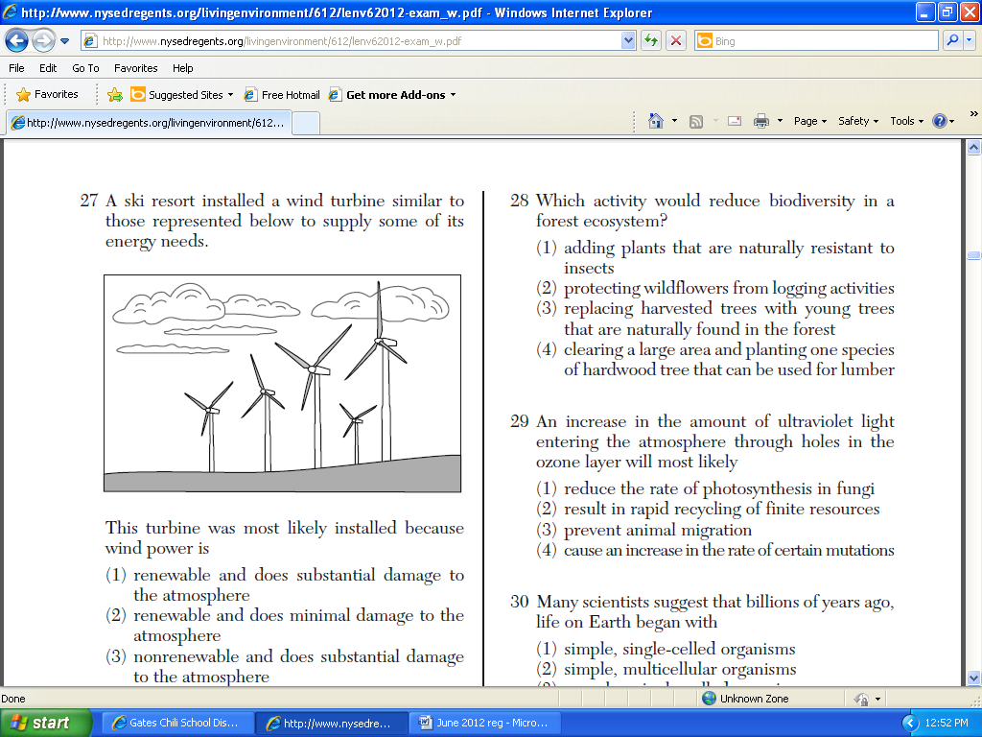

This turbine was most likely installed because wind power is

(1) renewable and does substantial damage to the atmosphere

(2) renewable and does minimal damage to the atmosphere

(3) nonrenewable and does substantial damage to the atmosphere

(4) nonrenewable and does minimal damage to the atmosphere

18.) One way humans can promote the survival of organisms in an ecosystem is to

(1) decrease diversity in plant habitats

(2) introduce new consumers to control autotrophs

(3) release extra CO2 into the atmosphere to help autotrophs

(4) learn about the interactions of populations

19.) Environmentalists are hoping to protect endangered organisms by calling for a reduction in the use of pesticides, because loss of these organisms would

(1) increase the mutation rate in plants

(2) cause pesticides to become more toxic to insects

(3) reduce biodiversity in various ecosystems

(4) decrease the space and resources available to other organisms

20.) Which farming practice causes the least harm to the environment?

(1) using natural predators to reduce insect numbers

(2) adding chemical fertilizers to all the crops in the area

(3) planting the same crop for 1 year on all the fields in the area

(4) planting the same crop in the same field each year for 10 years

21.) Which action by humans could improve the quality of the air?

(1) building homes that use only oil furnaces for heat

(2) buying cars that get more miles per gallon of gasoline

(3) increasing the number of coal-burning power plants that generate electricity

(4) cutting down forests to clear land for factories